<https://www.researchgate.net/figure/ESWH-daily-load-profile-in-winter-and-summer-2030_fig19_276916201>

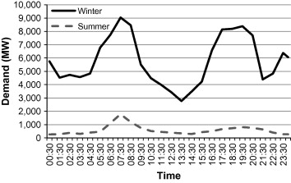

<https://www.researchgate.net/figure/The-electrical-load-profile-of-commercial-buildings-in-Jakarta-Indonesia_fig3_292670297>

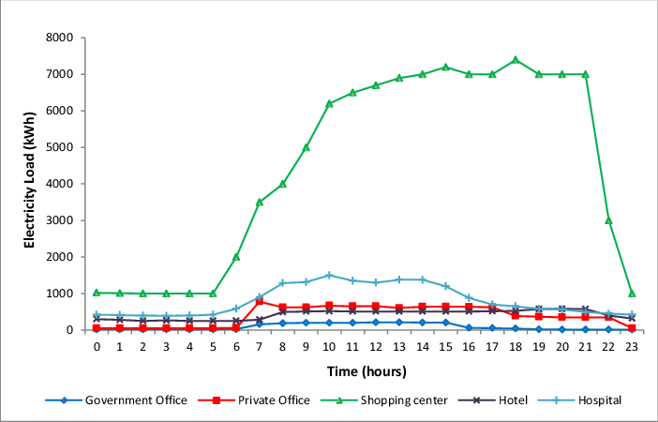

\<https://www.semanticscholar.org/paper/Load-profile-analysis-for-commercial-buildings-He-Liu/b30ba273119d512401064f748d9d3562f77712cc>

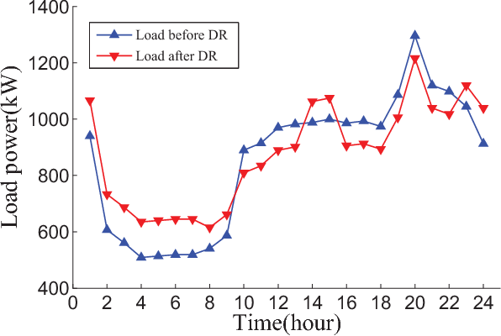

<http://www.huxham.com.au/our-services/energy-audits/>

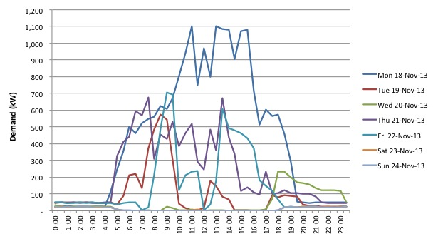

<https://www.sciencedirect.com/science/article/pii/S0360544216306533>

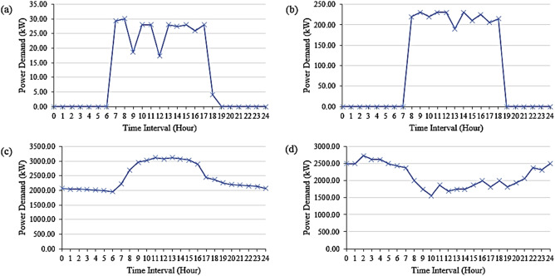

<https://www.sciencedirect.com/science/article/pii/S0973082618312559>

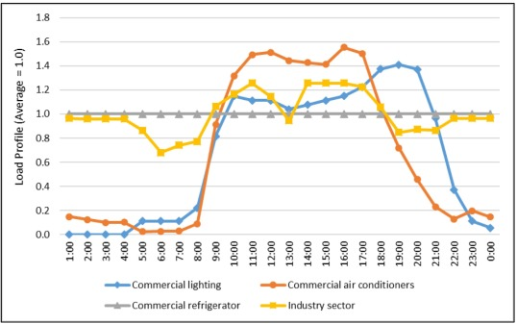

<https://www.slideshare.net/mohammadabdulhadi1/electric-load-patterns-for>

Industrial load patterns:
Industrial Load curve depends on work and break times, Weekends holiday and
Shifted group or sin...

<https://www.intechopen.com/books/energy-storage-technologies-and-applications/estimation-of-energy-storage-and-its-feasibility-analysis>

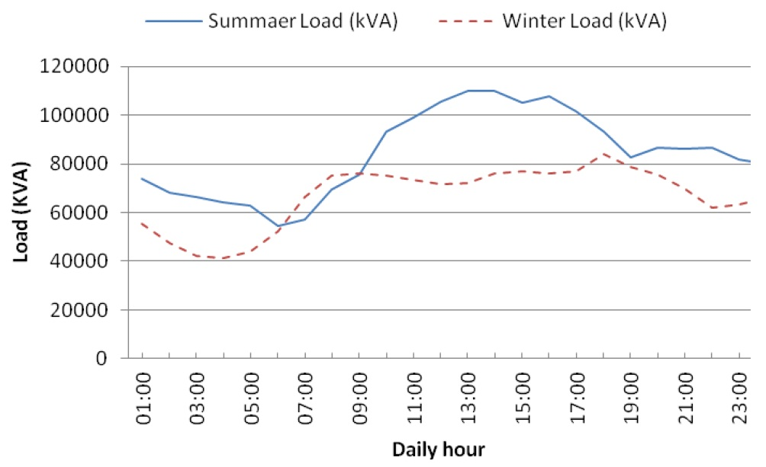

<https://www.researchgate.net/figure/Normalized-daily-power-profile-for-an-industrial-load_fig7_261058187>

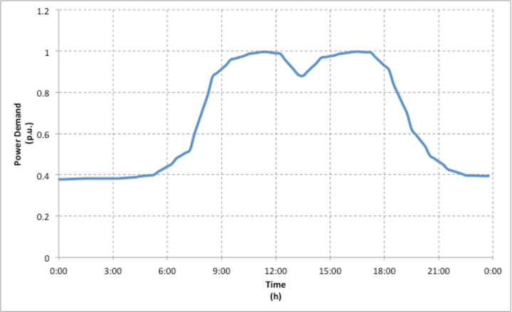

<https://www.intechopen.com/books/energy-storage-technologies-and-applications/estimation-of-energy-storage-and-its-feasibility-analysis>

